Changing the Data Source for a PBIX File

When you create a Power BI data model (PBIX file), you begin by choosing a data source. When you save the PBIX file, the path to the data source(s) used in the file are saved in the PBIX. There are many reasons you might wish to change your data source, including:

• To reconnect to a data source that has been moved or copied to a new location, for example, if you downloaded the exercise files for this course and wish to use the PBIX files that are included

• To use a more current set of data – *2021sales.xlsx* rather than *2020sales.xlsx*

• To use an entirely different set of data that contains the same columns, for example, using a report created fora particular SharePoint list with a different list with columns with the same names and data types

When you open a file and Power BI Desktop cannot connect to the report’s data source, it will display a Data Source Error on a yellow background at the top of the report window.

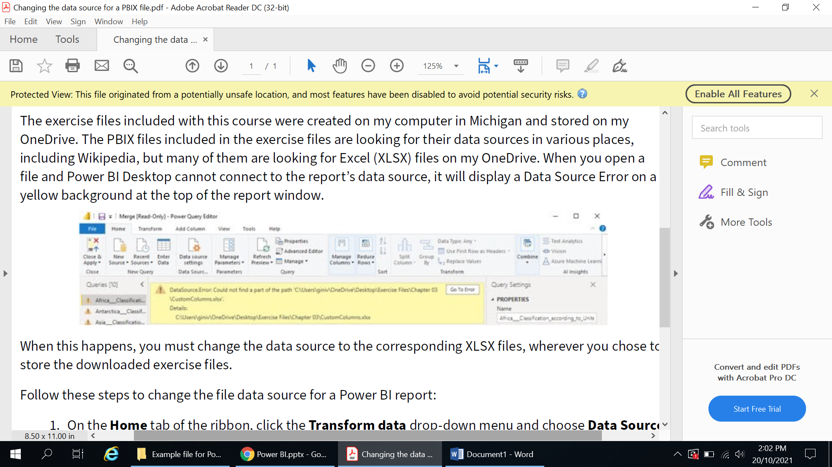

When this happens, you must change the data source to the corresponding XLSX files, wherever you chose to store the downloaded exercise files.

Follow these steps to change the file data source for a Power BI report:

1. On the **Home** tab of the ribbon, click the **Transform data** drop-down menu and choose **Data Source Settings** to open the **Data Source Settings** dialog box.

2. Select the data source you need to change, then click the **Change Source** button to open the dialog box for that data connection.

3. Browse to locate and select your new data source. Click **OK**.

